Summer Term 1 - Year 3
https://y3meadowside.edublogs.org/
Dates for your Diary:
Monday 17th April: Training Day (no children in school)
Tuesday 18th April: Back to School
Tuesday 18th and Wednesday 19th April: Parents’ Evenings
Thursday 27th April: FOM Cinema Night
Monday 1st May and Monday 8th May: Bank Holidays
Wednesday 17th May : Class Photos
Friday 26th May: Break up for Half Term

PE Information
All children will be going swimming at Knaresborough Pool for the next two terms (until July), on Monday afternoons. The lessons are taught by swimming instructors at the pool, and the children will be accompanied by Mrs Portway and Miss Tillett, as well as parent volunteers. Girls must wear a one-piece swimsuit, and boys must wear tight fitting shorts (not Bermuda style). All children must also have a swim hat. Please do talk to Mrs Portway if you have any questions or concerns.
On Tuesday afternoons, the children will have athletics with Mrs Portway, to prepare for Sports Day!
Please ensure all items of uniform are named (including P.E. kits).

Staffing
- Ms Ladden will be supporting in Year 3 every morning except for Thursday.
- Miss Tillett will be supporting Year 3 on Mondays and on Thursday mornings.
- Mrs Portway’s PPA will be covered by Miss Brown on Friday afternoons. She will teach Reading and Art.

Homework
- Homework folders are due in on Thursday, and handed out again on Friday.
- In Year 3, Homework is made up of spelling, times tables and reading.
- The children will have a spelling dictation (spelling test) on a Thursday.
- Children will swap their reading books on a Friday.
- If your child is reading Little Wandle books, please make sure these are returned by Wednesday.

Our Learning
We will start the term with RE week, focused on creation and our world. We will be learning about the Christian creation story, and thinking about how Christians protect the environment.
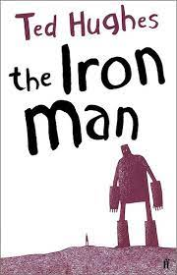
Our Big Idea this half term is “I am an eco-warrior.” In Geography, we will be learning about mountains, with a particular focus on Ben Nevis.. In Science, the children will learn about plants, considering the parts and functions of a plant, what plants need to survive, and the process of pollination and fertilisation.
Linked to our Big Idea, our English learning will be inspired by the classic text The Iron Man by Ted Hughes. The children will use the text as inspiration to write a newspaper article, as well as a science-fiction narrative of their own.
In Maths, we will finish our fractions topic, before moving onto time. Please do spend some time with your child practicing reading an analogue clock if you can.
In Art, the children will be looking at sculpture, inspired by Roald Dahl’s The Minpins. In Computing, we will be focusing on e-mail and e-mail safety. In Music, we will be learning a disco song called Bringing Us Together, as well as composing and performing our own music. In French, we will focus on school, looking at items in our classroom, school subjects, and our opinions about school.
For more information, please see the Medium Term Plan on the website.

Supporting Your Child in Maths
As part of your child’s maths learning, it would be brilliant if you could support at home with the following:
Times Tables. Children in Year 3 need to be confident in their 3, 4 and 8 times tables, as well as the 2, 5 and 10 times tables they learnt in Year 2. This will give them a strong foundation for Year 4, where they need to know all their tables up to 12 x 12.
Children can practise their tables in a number of different ways. Each child has a TT Rockstars account, or can play Hit the Button (Topmarks website). Some children might also find writing their tables down, singing tables songs, or quizzing in the car helpful as well!

Telling the Time. Later on in the term, we will be studying telling the time in Maths. This can be a difficult topic for many children, particularly as they are less exposed to analogue clocks than previous generations! If you are able to, it would be wonderful if you could spend some time looking at clocks, pointing out the time during the day etc. Please also practise the 5 times table with your child up to 60, and make sure they are strongly secure in this.
https://home.oxfordowl.co.uk/maths/learning-to-tell-the-time/
Thank you for your continued support with your child’s learning!

Useful Website Links
Purple Mash: We use Purple Mash for our computing and spelling lessons. Children can practice their spellings using the spelling quizzes, as well as trying out lots of curriculum activities:
https://www.purplemash.com/sch/meadowside-hg5
Dance Mat Typing: Dance Mat Typing is a fun, free typing program from the BBC https://www.bbc.co.uk/bitesize/topics/zf2f9j6/articles/z3c6tfr

TT Rockstars: Children can use TT Rockstars to practice their times tables:
https://play.ttrockstars.com/auth/school/student/18128
Reading Plus: Children will complete assessments at school this half term, and then will be able to use Reading Plus at home:
https://student.readingplus.com/seereader/api/sec/login
Site Code: rpmeado12
Marvellous Me: Marvellous Me is an app which allows you to communicate with your child’s teacher. Individual join codes will be given in the first few weeks of term.
https://marvellousme.com/

The mindful approach to P.S.H.E.
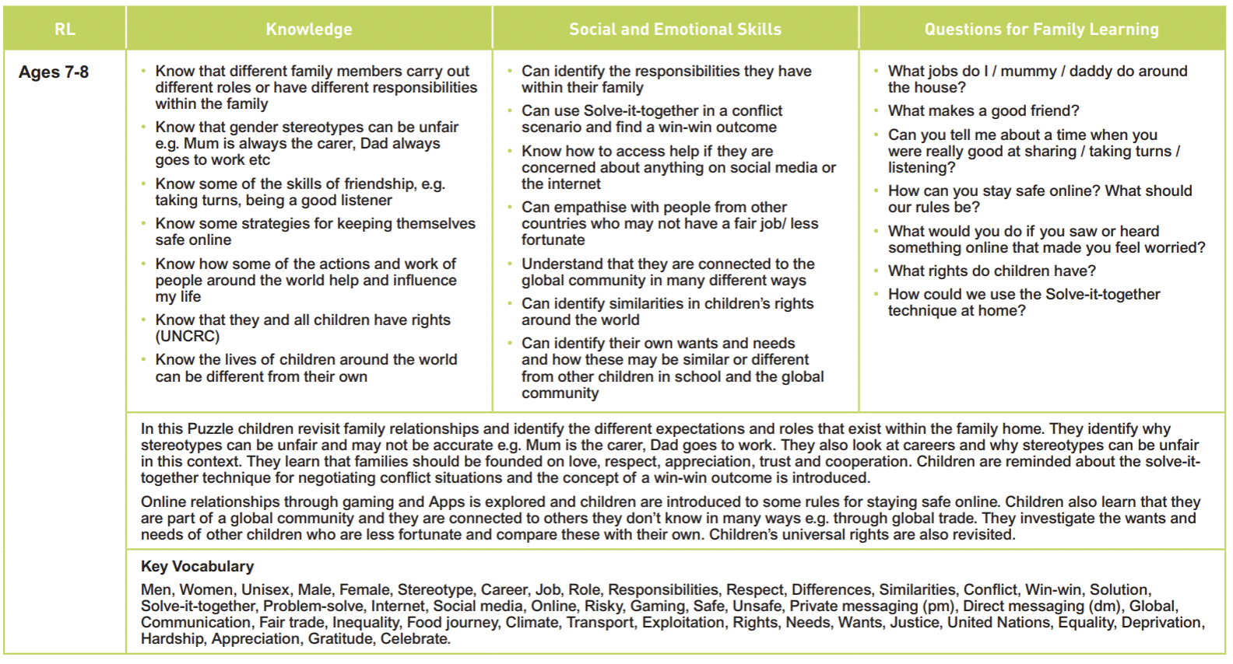
Relationships: Year 3

