Spring Term 1 - Year 3
https://y3meadowside.edublogs.org/

Dates for your Diary:
Monday 20th February: Return to School
Thursday 2nd March: World Book Day
Friday 31st March: Last Day of Term
Monday 17th April: Teacher Training Day (School Closed)
Tuesday 18th April: Return to School

Key Information
P.E. this half-term will be based around netball. The children will have two sessions led by Mrs Portway on Tuesday and Wednesday afternoons.
On Monday afternoons, the children will be taught by Miss Brown. This term, she will be teaching Art.
In Year 3, children are not provided with a snack in the morning. They are welcome to bring in their own fruit and vegetables to eat during Morning break.
Please ensure all items of uniform are named (including P.E. kits). Please also make sure your child has a pair of wellies for Forest school/Welly Play.We have lots of spares at school, so please ask if you need a pair.

Homework
- Homework folders are due in on Thursday, and handed out again on Friday.
- In Year 3, Homework is made up of spelling, times tables and reading.
- The children will have a spelling dictation (spelling test) on a Thursday.
- Children will swap their reading books on a Friday.

/

Reading
- Banded Reading books/Free Readers are taken home on a Friday. Children’s book bands will be reviewed regularly.
- Each child will have a Book Club book that they will read and discuss at school. These will be changed each half term. Please see the Medium Term Plan for more information.
- All children will bring a Reading for Pleasure book from the library home each week. Please make sure these are returned!

Our Learning
We will start the term with RE week, focused on questions that puzzle us. We will learn about Christian and Jewish festivals of commitment.
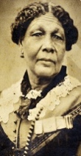
Our Big Idea this half term is “I am part of a diverse world.” In History, we will be learning about Mary Seacole, and discussing why she is a significant person. As part of Culture Week, the children will be focusing on Place Geography, comparing Warsaw, Poland with Leeds. In Science, the children will learn about Marie Curie and George Washington Carver, as well as practicing their working scientifically skills in investigations.
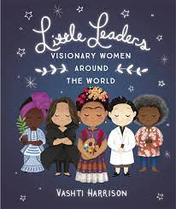
Linked to our Big Idea, our English learning will be inspired by two high quality texts, The Little Leaders series by Vashti Harrison, and the poetry of Grace Nichols. Inspired by these texts, we will create our biographies of Mary Seacole and poems.
In Maths, we will finish length and perimeter, before moving on to fractions.
In Art, the children will be looking at printmaking. In Computing, we will be focusing on touch typing. In Music, we will be learning some songs from musicals as well as continuing with the glockenspiel. In French, we will focus on numbers and counting.
For more information, please see the Medium Term Plan on the website.

Useful Website Links
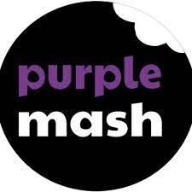
Purple Mash: We use Purple Mash for our computing and spelling lessons. Children can practice their spellings using the spelling quizzes, as well as trying out lots of curriculum activities:
https://www.purplemash.com/sch/meadowside-hg5
Dance Mat Typing: Dance Mat Typing is a fun, free typing program from the BBC https://www.bbc.co.uk/bitesize/topics/zf2f9j6/articles/z3c6tfr

TT Rockstars: Children can use TT Rockstars to practice their times tables:
https://play.ttrockstars.com/auth/school/student/18128
Reading Plus: Children will complete assessments at school this half term, and then will be able to use Reading Plus at home:
https://student.readingplus.com/seereader/api/sec/login
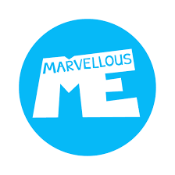
Site Code: rpmeado12
Marvellous Me: Marvellous Me is an app which allows you to communicate with your child’s teacher. Individual join codes will be given in the first few weeks of term.
https://marvellousme.com/

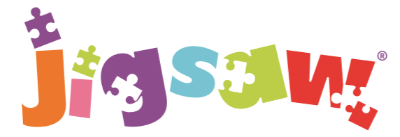
The mindful approach to P.S.H.E.
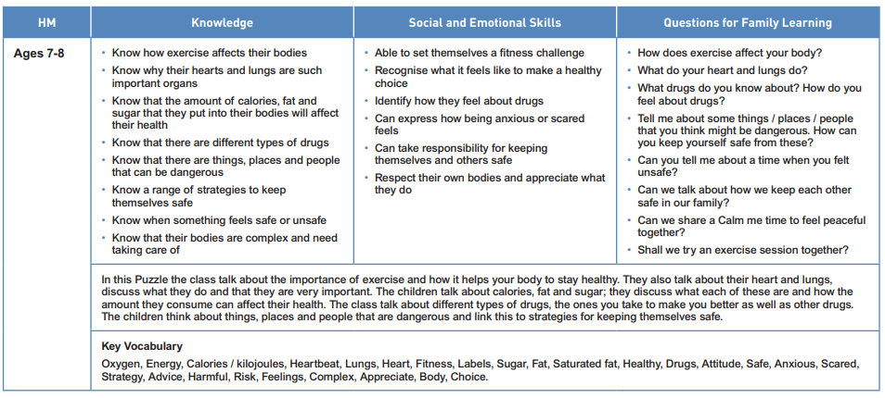
Healthy Me: Year 3

