I am part of a diverse world
Environment/Global Learning/Local Community

Week 1: RE Week –

Passion for Learning:

Launch:
Re-launch:
Landing:

Our Values
Relationships and Respect
Our Curriculum Drivers
Resilience, Resourcefulness, Reflectiveness
This Term’s Focus – Reflection and Resourcefulness

Topic/Unit Titles  National Curriculum Objectives | Week 1 –  R.E. Week | Week 2 –  LAUNCH | Week 3 – |  |  | Week 4 –  RE- LAUNCH |  | Week 5 – |  | Week 6 –
English  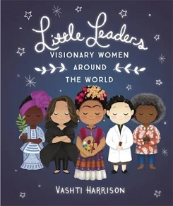  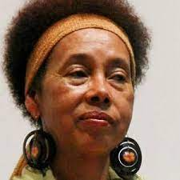 | RE Texts:  Bar and Bat Mitzvahs by Robert Walker  Bubbe’s Belated Bat Mitzvah by Isabel Pinson | High Quality Text: Little Leaders Series by Vashti Harrison |  |  |  |  |  | High Quality Text: Grace Nichols Poetry
 |  | Collect Week  - I can explore visual literacy  - I can retrieve and record information from a non-fiction text.  - I can analyse the structure of a text.  Connect Week  - I can use sub-headings.  - I can organise paragraphs.  - I can use interesting sentence openers  Create Week  Text Type: Biography  Plan a biography of Mary Seacole, using paragraphs.  Draft and Write a biography inspired by Little Leaders  Evaluate and Edit my writing for sense.  Publish my writing |  |  |  |  |  | Collect  - I can read a range of poems by Grace Nichols.  - I can explain and justify my opinion about poems.  - I can use poetry as a stimulus for drama.  Connect  - I can analyse the structure of a poem.  - I can create expanded noun phrases.  - I can use interesting adjectives to describe.  Create  Text Type: Poem  Plan a poem using verbal rehearsal.  Draft and Write a poem inspired by Grace Nichols’ Alligator Mama.  Evaluate and Edit my poem.  Perform my poem to an audience of peers
Whole Class Reading  READING DOMAINS: VOCABULARY, INFERENCE, PREDICTION, EXPLANATION, RETRIEVAL, SEQUENCING AND SUMMARISING (VIPERS)  Vocabulary covered in each theme. | Based on RE Texts | Theme: Little Leaders Series (Non-Fiction Biography)  Key Domains: Explanation and Summarising. |  |  |  |  | Theme: Poetry (John Agard)  Key Domains: Inference and Structure | Theme: Poland (Information Texts)  Key Domains: Retrieval and Explanation | Key Domains: Poetry (Jackie Kay)  Key Domains: Inference and Prediction
Spelling Rule  PURPLE MASH SPELLING SCHEME  (All children will be exposed to these words and their meanings. Words for spelling tests for each group can be found below) | -tion endings | -sion endings |  | Prefix re- |  |  | Year 3 and 4 Common Exception Words | -ture and -sure | Consolidation and Assessment
Maths | Length and Perimeter  -Compare Lengths  - Add Lengths  -Subtract Lengths  -Measure Perimeter  -Calculate Perimeter |  |  |  | Fractions Unit 1  -Make Equal Parts  -Recognise and find a half.  -Recognise and find a quarter  - Recognise and find a third  - Unit Fractions  - Non-Unit fractions  - Equivalence of half and 2-quarters  - Count in fractions |  |  | -Fractions Unit 2  -Making the whole  - Tenths  -Count in tenths  -Tenths as decimals  - Fractions of a set of objects
P.S.H.E.  JIGSAW: Healthy Me  PSHE LO  Social and Emotional Development LO | Being Fit and Healthy  -I understand how exercise affects my body and know why my heart and lungs are such important organs.  -I can set myself a fitness challenge.  CELEBRATE:  Make a healthy choice. | Being Fit and Healthy  -I know that the number of calories, fat and sugar I put into my body will affect my health.  -I know what It feels like to make a healthy choice.  CELEBRATE:  Eat a healthy, balanced diet. |  | What do I know about drugs?  -I can tell you my knowledge and attitude towards drugs.  -I can identify how I feel towards drugs.  CELEBRATE:  Been physically active. |  |  | Being Safe  -I can identify things, people and places that I need to keep safe from.  -I know who to ask for help, and how to call 999.  -I can express how being anxious or scared feels.  CELEBRATE:  Tried to keep themselves and others safe. | Safe or Unsafe  -I can identify when something feels safe or unsafe.  -I can take responsibility for keeping myself and others safe.  CELEBRATE:  Know how to be a good friend and enjoy healthy friendships. |  | My Amazing Body  -I understand how complex my body is and how important it is to take care of it.  -I respect my body and appreciate what it does for me.  CELEBRATE:  Help others to achieve their goals.
R.E.  QUESTIONS THAT PUZZLE US  KEY QUESTION: WHY DO SOME PEOPLE THINK THAT LIFE IS A JOURNEY? WHAT SIGNFICANT EXERIENCES MARK THIS?  (Focus on Christianity and Judaism) | .  -I can suggest why people see life as a journey and identify some of the key milestones of this journey.  -I can describe what happens in Christian and Jewish ceremonies of commitment and say what these rituals mean.  -I can suggest reasons why marking the milestones of life are important to Christian and Jewish people.  -I can link up some questions and answers about how believers show commitment with my own ideas about community, belonging and belief.
Science:  SCIENTISTS AND INVENTORS  (With one-off investigations to practise working scientifically) |  | Science Investigation |  | Marie Curie - Chemist |  |  | Science Investigation | George Washington-Carver - Agriculturalist
History  BRITISH BLACK HISTORY: MARY SEACOLE |  | When and where did Mary Seacole live? |  | What was life like for Mary Seacole? |  |  | What do sources tell us about Mary Seacole’s achievements? |  |  | Why do people see Mary Seacole as significant?
Geography  PLACE GEOGRAPHY: CULTURE WEEK |  |  |  |  |  |  |  | Culture Week – Comparing Warsaw, Poland to Leeds.
Art

Printmaking

French

Music | Glockenspiel (Charanga)  Listen and Appraise – Begin to recognise styles, find the pulse, recognise instruments, discuss, listen, discuss other dimensions of music.  Games – continue to internalise, understand, feel, know how the dimensions of music work together. Learn about pulse, rhythm, pitch, temp, dynamics.  Playing – Continue to play a classroom instrument in a group. Explore the link between sound and symbol.  Improvisation and Composition – Continue to explore and create responses, melodies and rhythms. Record in different ways.  Perform/Share – Continue to work together in a group and perform to each other and audiences. Discuss/Respect/Improve our work together.
Singing (Songs from Musicals)
- Sing with a good sense of pulse and sing together in time with a group.
-Follow a leader/conductor
Computing | Touch Typing – Using Dance Mat Typing  - Learn how to use the home row keys.  - Learn how to type e,I,r and u  - Learn the six keys above the home row (t,y,w,o,q and p)
Physical Education  HEALTH RELATED EXERCISE/SWIMMING | Health Related Exercise  -Take part in outdoor and adventurous activity challenges both individually and as a team.  -Compare their performance with previous ones and demonstrate improvement to achieve their personal best.  Swimming  -Swim competently over a distance of at least 25 metres, beginning to explore a range of strokes effectively.

Spelling Words for Assessment (Bears Group):
Year 3 and 4 Common Exception Words
Week 1 | Week 2 | Week 3 | Week 4 | Week 5 | Week 6
action  mention  position  solution  fiction  option  caution  relation  introduction  construction | expansion  extension  comprehension  tension  suspension  apprehension  dimension  pension  diversion  confession | redo  refresh  return  reappear  redecorate  replay  reaction  review  recycling  rebound | imagine  decide  group  learn  weight  build  early  island  grammar  therefore | measure  treasure  pleasure  enclosure  creature  furniture  picture  nature  adventure  feature | Consolidation

Spelling Words for Assessment (Tigers Group):
Common Exception Words
Week 1 | Week 2 | Week 3 | Week 4 | Week 5 | Week 6
Focus: The possessive apostrophe  Megan’s  Ravi’s  girl’s  child’s  man’s  boy’s  bike’s  computer’s  school’s  parent’s | Focus: Adding -ed, -ing, -er and -est to a root word ending in -y.  copied  copier  happier  happiest  cried  replied  copying  crying  replying  relied | Adding the endings -ing, -ed, -er, -est and -y to words ending in -e with a consonant before it.  hiking  hiked  hiker  nicer  nicest  shiny  describing  described  wiring  tiled | Adding -ing, -er, -est and -y to words of one syllable ending in a single consonant letter after a single vowel letter.  patting  patted  humming  hummed  dropping  dropped  sadder  saddest  fatter  fattest | Exception words list  every  everybody  even  great  break  from  pretty  beautiful  after  fast  asked | Consolidation  him  them  down  child’s  replying  describing  patted  dropped  everybody  after

Spelling Words for Assessment (Lions Group):
Common Exception Words
Week 1 | Week 2 | Week 3 | Week 4 | Week 5 | Week 6
Focus: oa, oe and ow vowel digraph  boat  coat  road  coach  goal  toe  goes  own  snow  grow | ou and ow vowel digraphs with /ow/ sound  out  about  mouth  around  sound  now  how  brown  down  town | ue and ew vowel digraphs  blue  clue  true  rescue  Tuesday  new  few  grew  flew  drew | ear and igh trigraphs  high  night  light  bright  right  dear  hear  beard  near  year | Exception words list  your  they  be  he  me  she  we  no  go  so  that  an | or digraph and ore trigraph  for  short  born  horse  morning  more  score  before  wore  shore

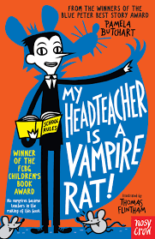
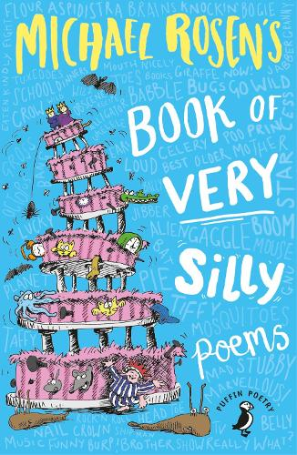
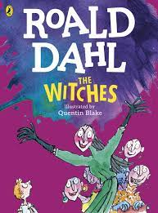
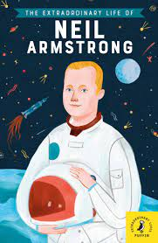
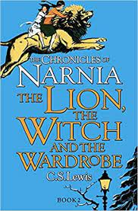
Year 3 Book Club:

