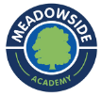Spring Term 1 - Year 3
https://y3meadowside.edublogs.org/

Dates for your Diary:
Tuesday 3rd January: School Opens
Thursday 5th January: Young Voices/ Skip 2 B Fit Workshops
Thursday 26th January: Mrs Gale Coffee Morning
Monday 30th January – Friday 3rd February: Storytelling Week
Friday 10th February: Last day of term.

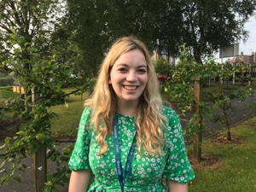
Our Classroom Staff This Term

Mrs Portway is our class teacher.
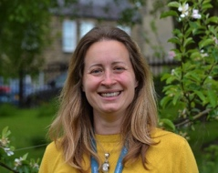
Miss Brown will be teaching Art/DT on Monday afternoons.

Mrs Ladden is our new TA, and will be with us in the morning on Monday-Thursday. Mrs Ladden is also our Head Midday Supervisor, so many of the children know her well.

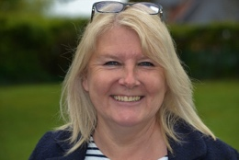
We are very lucky to still have Miss Tillett on Monday and Friday mornings. Miss Tillett will continue to help to lead our Maths and Reading interventions.

In the next few weeks, we will also welcome an Undergraduate student into our class. Miss Hinchcliffe will be leading small groups and teaching the class, under the supervision of Mrs Portway.

Key Information
P.E. this half-term will be based around football. The children will have PE with Mrs Portway on Wednesday afternoons, and with our football coach Mr Lofthouse on Friday mornings.
On Monday afternoons, the children will be taught by Miss Brown. This term, she will be teaching Art.
In Year 3, children are not provided with a snack in the morning. They are welcome to bring in their own fruit and vegetables to eat during Morning break.
Please ensure all items of uniform are named (including P.E. kits). Please also make sure your child has a pair of wellies for Forest school/Welly Play.We have lots of spares at school, so please ask if you need a pair.

Homework
- Homework folders are due in on Thursday, and handed out again on Friday.
- In Year 3, Homework is made up of spelling, times tables and reading.
- The children will have a spelling dictation (spelling test) on a Thursday.
- Children will swap their reading books on a Friday.

/

Reading
- Banded Reading books/Free Readers are taken home on a Friday. Children’s book bands will be reviewed regularly.
- Each child will have a Book Club book that they will read and discuss at school. These will be changed each half term. Please see the Medium Term Plan for more information.
- All children will bring a Reading for Pleasure book from the library home each week. Please make sure these are returned!

Our Learning

We will start the term with RE week, focused on celebrations. We will learn about the Hindu festivals of Diwali, Holi and Raksha Bandhan, and compare them to our own celebrations.
Our Big Idea this half term is “I am an artist.” We will take lots of opportunities to perform and take part in drama in English, RE and Music. In Geography, we will be looking at locational knowledge, focused mainly on Europe. In Science, we will cover forces and magnets
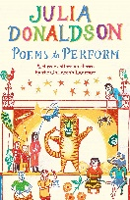
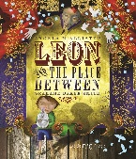
Linked to our Big Idea, our English learning will be inspired by two high quality texts, Leon and the Place Between by Angela McAllister, and Poems to Perform, chosen by Julia Donaldson. Inspired by these texts, we will create our own fantasy narratives and poems. We are planning to invite the parents to a Poetry Picnic at the end of term!
In Maths, we will finish multiplication and division, before moving on to look at money. We will finish by focusing on statistics.
In DT, the children will be designing and making toys with a pneumatic system. In Computing, we will continue with our coding, as well as learning how to touch type. In Music, we will be learning the song Three Little Birds, as well as continuing with the glockenspiel. In French, we will focus on animals and colours.
For more information, please see the Medium Term Plan on the website.

Useful Website Links
Children will be given their log-ins and passwords in the first few weeks of term.
Purple Mash: We use Purple Mash for our computing and spelling lessons. Children can practice their spellings using the spelling quizzes, as well as trying out lots of curriculum activities:
https://www.purplemash.com/sch/meadowside-hg5

TT Rockstars: Children can use TT Rockstars to practice their times tables:

https://play.ttrockstars.com/auth/school/student/18128
Reading Plus: Children will complete assessments at school this half term, and then will be able to use Reading Plus at home:
https://student.readingplus.com/seereader/api/sec/login
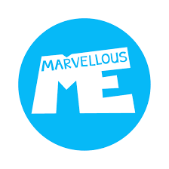
Site Code: rpmeado12
Marvellous Me: Marvellous Me is an app which allows you to communicate with your child’s teacher. Individual join codes will be given in the first few weeks of term.
https://marvellousme.com/

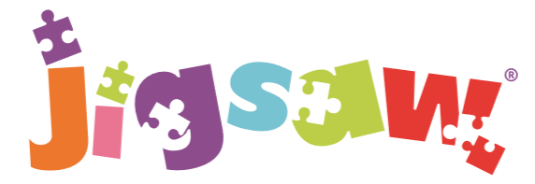
The mindful approach to P.S.H.E.
Dreams and Goals: Year 3
