I am an Artist
Environment/Global Learning/Local Community

Week 1: RE Week –
5th Jan – Young Voices
5th Jan – Skip 2 B Fit Day
9th Jan – Curling Competition (Some children)
Wb 30th Jan – Storytelling Week
3rd Feb – NSPCC Number Day
Passion for Learning:

Launch: Young Voices/Skip 2 B Fit Day
Re-launch: Storytelling Week
Landing: Poetry Picnic (with parents)

Our Values
Relationships and Respect
Our Curriculum Drivers
Resilience, Resourcefulness, Reflectiveness
This Term’s Focus – Respect and Relationships

Topic/Unit Titles  National Curriculum Objectives | Week 1 –  R.E. Week | Week 2 –  LAUNCH | Week 3 – |  | Week 4 –  RE- LAUNCH |  | Week 5 – |  |  |  | Week 6 –
English  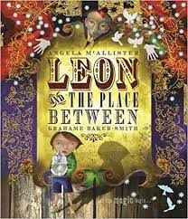  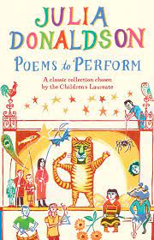 | RE Texts:  Celebrations in My World: Diwali by Kate Torpie  Bracelets for Bina’s Brothers by Rajani LaRocca.  Celebrations in My World: Holi by Lynn Peppas | High Quality Text: Leon and the Place Between by Angela McAllister |  |  |  |  |  | High Quality Text: Poems to Perform, chosen by Julia Donaldson
 |  | Collect Week  -I can use my senses to describe a scene.  -I can collect nouns and verbs  -I can make plausible inferences about a character’s emotions throughout a text.  Connect Week  -I can select words and phrases for clarity and impact.  -I can use adverbs and adverbial phrases to describe when, where and how.  -I can create figurative expanded noun phrases.  - I can punctuate direct speech.  Create Week  Text Type: Narrative  Plan writing by innovating a known structure.  Draft and Write creating settings, characters and plots.  Evaluate and Edit by proof-reading for spelling and punctuation errors, and proposing changes to grammar and vocabulary to improve consistency. |  |  |  |  |  | Collect  -I can read and enjoy a range of poems by different authors.  -I can read poetry aloud, thinking about tone, volume, and intonation.  - I can discuss different structures of poetry.  Connect  -I can select and use a range of interesting vocabulary  -I can use rhyme.  Create  Text Type: Poem  Plan writing by innovating a known structure.  Draft and Write a poem.  Evaluate and Edit by proof-reading for spelling and punctuation, and suggesting improvements to their own and their peers’ writing.  Perform my poem to my classmates, considering tone, volume and intonation.
Whole Class Reading  READING DOMAINS: VOCABULARY, INFERENCE, PREDICTION, EXPLANATION, RETRIEVAL, SEQUENCING AND SUMMARISING (VIPERS)  Vocabulary covered in each theme. | Based on RE Texts | Theme: Classic Literature  The Three Musketeers, adapted from Alexandre Dumas  Key Domain:  Inference |  |  |  | Theme: Information Text  The Geography of Europe by Miriam Coleman  Key Domain: Summarising and Explanation |  | Theme: Poetry  Poems to Perform by Julia Donaldson  Key Domains:  Structure and Vocabulary
Spelling Rule  PURPLE MASH SPELLING SCHEME | Recap Autumn Term | Prefix: super- |  | Prefix: im- |  | Year 3 and 4 Common Exception Words |  | Ending ‘sion’ |  | Consolidation/ Assessment
Maths | Multiplication and Division:  -Scaling  -How many ways. | Money  -Pounds and Pence  -Convert Pounds and Pence  -Add Money  -Subtract Money  - Subtract Money (crossing the pound boundary)  - Give Change |  |  |  | Statistics  -Collect data in a tally chart.  -Collate data in a frequency table.  -Create simple bar charts.  -Create simple Pictograms. |  |  | Length and Perimeter  -Measure Length  -Equivalent Lengths m and cm  -Equivalent Lengths mm and cm  - Add lengths  - Subtract lengths  - Measure Perimeter  - Calculate Perimeter
P.S.H.E.  JIGSAW: DREAMS AND GOALS  PSHE LO  Social and Emotional Development LO | Dreams and Goals  -I can tell you about a person who has faced difficult challenges and achieved success.  -I respect and admire people who overcame obstacles to achieve their dreams and goals.  CELEBRATE:  Stay motivated when doing something challenging. | My Dreams and Ambitions  -I can identify a dream/ambition that is important to me.  -I can imagine how I will feel when I achieve my dream/ambition  CELEBRATE:  Keep trying even when it is difficult. |  | A New Challenge  -I enjoy facing new learning challenges and working out the best ways for me to achieve them.  -I can break down a goal into a number of steps and know how others could help me to achieve it.  CELEBRATE:  Work well with a partner or in a group. |  | Our New Challenge  -I can be motivated and enthusiastic about achieving our new challenge.  -I know that I am responsible for my own learning and can use my strengths as a learner to achieve the challenge.  CELEBRATE:  Have a positive attitude |  | Our New Challenge – Overcoming Obstacles  -I can recognise obstacles which might hinder my achievement and take steps to overcome them.  -I try hard not to use hurtful words.  CELEBRATE:  Help others to achieve their goals. |  |  | Celebrating My Learning  -I can evaluate my own learning process and identify how it can be better next time.  -I can be confident in sharing my success with others.  CELEBRATE:  Are working hard to achieve their own dreams and goals.
R.E.  CELEBRATIONS:  KEY QUESTION: WHY ARE FESTIVALS IMPORTANT TO HINDUS? | -I can discuss how I/my family celebrates significant events/people.  -Consider the meanings of the stories behind Diwali, Holi and Raksha Bandhan.  -Describe how believes express the meaning of religious festivals through symbols, sounds, actions, stories and rituals.  -Study key elements of a festival.  -Explore the benefits of celebrations to religious communities.
Science:  FORCES AND MAGNETS  National Curriculum Objectives  -Compare how things move on different surfaces.  -Notice that some forces need contact between 2 objects, but magnetic forces can act at a distance.  -Observe how magnets attract or repel each other, and attract some materials and not others.  -Compare and group together a variety of everyday materials on the basis of whether they are attracted to a magnet, and identify some magnetic materials.  -Describe magnets as having two poles.  -Predict whether 2 magnets will attract or repel each other, depending on which poles are facing. |  | Pushes and Pulls  -I can identify the forces acting on objects. |  | Faster and Slower  Investigation  -I can investigate how a toy car moves over different surfaces. |  | Scrapyard Challenge  Investigation  -I can sort magnetic and non-magnetic materials. |  | Magnetic Poles  -I can explore magnetic poles |  |  | Magnetic Games  Investigation  -I can observe how magnets attract some materials, by making a game.
Geography  LOCATIONAL GEOGRAPHY |  | Continents and Oceans  (Revision from Yr 2) – I can name and locate the 7 continents and 5 oceans.  -I can locate Europe on a map. |  | World Greatest…  -I can investigate the largest desert, highest mountain and longest river in the world. |  | Europe  -I can locate some key countries on a map of Europe. |  | European Cities  -I know some key facts about some cities in Europe.  -I can compare similarities and differences between these cities.
Art | - Animated drawings linked to DT topic.  - Artist Study
DT  MOVING MECHANISMS | Pneumatic Toys  - I can draw accurate diagrams with correct labels, arrows, and explanations.  - Correctly identify definitions for key terms.  - Identify appropriate design criteria  - Use thumbnail sketches and exploded diagrams.  - Select appropriate equipment and materials to build a working pneumatic system.  - Create a finished pneumatic toy that fulfils the design brief.
French | -To learn some key classroom language. | -To learn some French animals |  | -To learn how to make plurals in French |  | -To learn the articles un, une, des, le, la, les |  | -To learn the adjectives of colour. |  |  | To listen to a French story.
Music | Glockenspiel (Charanga)  Listen and Appraise – Begin to recognise styles, find the pulse, recognise instruments, discuss, listen, discuss other dimensions of music.  Games – continue to internalise, understand, feel, know how the dimensions of music work together. Learn about pulse, rhythm, pitch, temp, dynamics.  Playing – Continue to play a classroom instrument in a group. Explore the link between sound and symbol.  Improvisation and Composition – Continue to explore and create responses, melodies and rhythms. Record in different ways.  Perform/Share – Continue to work together in a group and perform to each other and audiences. Discuss/Respect/Improve our work together.
Singing (Three Little Birds)
- Sing with a good sense of pulse and sing together in time with a group.
-Follow a leader/conductor
Computing | Touch Typing  - Introduce typing terminology  - Understand the correct way to sit at a keyboard.  - Learn how to use the home, top and bottom row keys.  - Practice typing with both left and right hands. |  |  |  |  |  |  | Coding Crash Course  Use of the PRIMM Approach:  Predict what your code will do.  Run the code to check your prediction.  Investigate trace through the code to see if you were correct.  Modify the code to add detail, change actions/outcomes.  Make a new program that uses the same ideas in a different way.
Physical Education  FOOTBALL | Football  - Use running, jumping, throwing and catching in isolation and in combination.  - Play competitive games, modified where appropriate.  - Listen to feedback about their performance.
Spelling Words for Assessment:
Year 3 and 4 Common Exception Words
Week 1 | Week 2 | Week 3 | Week 4 | Week 5 | Week 6
optician  pyramid  trouble  country  incomplete  mail  male  piece  vein  parachute | supermarket  superstar  superman  superhuman  supersonic  superfine  superficial  supercomputer  supertanker  superstructure | immature  impossible  impatient  imperfect  immortal  impolite  immovable  improbable  imbalance  impeccable | appear  material  library  perhaps  sentence  various  regular  bicycle  possess  caught | division  invasion  confusion  decision  collision  television  abrasion  expansion  erosion  excursion | Consolidation

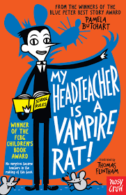
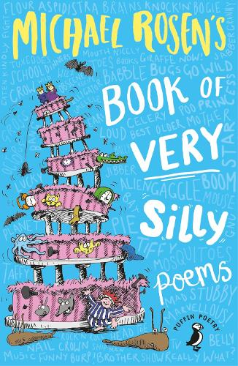
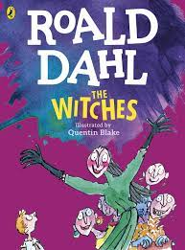
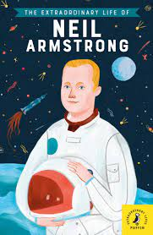
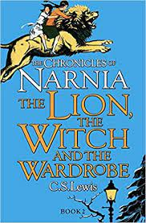
Year 3 Book Club:

