Autumn Term 2 - Year 3
https://y3meadowside.edublogs.org/
Dates for your Diary:
4th November: RE Exhibition for Parents
11th November: Remembrance Day and Poppy Walk
18th November: Children in Need
8th December: Flu Vaccinations
9th December: Reports sent home
10th December: FOM Christmas Fair
12th December: Year 3 Christmas Party
16th December: Last Day of School

Key Information
P.E. this half-term will be based around Zumba and Gymnastics. The children will have Zumba with Richard Weaver Dance Studio on Tuesday afternoons, and gymnastics with Total Sports on Friday mornings.
On Monday afternoons, the children will be Art by Miss Brown.
In Year 3, children are not provided with a snack in the morning. They are welcome to bring in their own fruit and vegetables to eat during Morning break.
Please ensure all items of uniform are named (including P.E. kits). Please also make sure your child has a pair of wellies for Forest school/Welly Play.We have lots of spares at school, so please ask if you need a pair.

Homework
- Homework folders are due in on Thursday, and handed out again on Friday.
- In Year 3, Homework is made up of spelling, times tables and reading.
- The children will have a spelling dictation (spelling test) on a Thursday.
- Children will swap their reading books on a Friday.

Reading
- Banded/Levelled Reading books are taken home on a Friday. Children’s book bands will be reviewed regularly.
- This term, children will also have a Book Club book that they will read at home and school. Please make sure these are in school each day.
- All children will bring a Reading for Pleasure book from the library home each week on a Thursday/Friday. Please make sure these are returned!

Our Learning

We will start the term with RE week, focused on life as a Christian. We will be learning all about what it is like to be a Christian in Britain today. We will also be taking part in whole-school activities around Diwali.
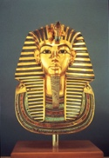
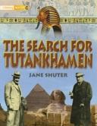
Our Big Idea this half term is “I am an explorer.” In History, we will be learning about Ancient Egypt. In Science we will focus on Light and Shadow. We will also cover lots of locational Geography objectives, and spend lots of time in Outdoor Learning in all subjects!
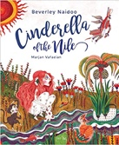
Linked to our Big Idea, our English learning will be inspired by two high quality texts, Cinderella of the Nile by Beverley Naidoo, and The Search for Tutankhamen by Jane Shuter. Inspired by these books, we will create innovated traditional tales and information texts.
In Maths, we will finish our Addition and Subtraction learning, before moving onto Multiplication and Division. We will introduce our 4 and our 8 times tables.
In Art, we will be focusing on colour. In Computing, we will finish our Coding topic, before moving onto Spreadsheets. In Music, we will be learning how to play the glockenspiel, as well as learning the songs for Young Voices. In French, we will look at numbers, what’s in my pencil case, and French Christmas.
For more information, please see the Medium Term Plan on the website.

Useful Website Links
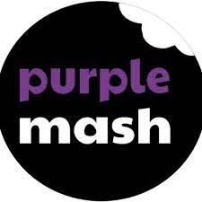
Children will be given their log-ins and passwords in the first few weeks of term.
Purple Mash: We use Purple Mash for our computing and spelling lessons. Children can practice their spellings using the spelling quizzes, as well as trying out lots of curriculum activities:
https://www.purplemash.com/sch/meadowside-hg5

TT Rockstars: Children can use TT Rockstars to practice their times tables:

https://play.ttrockstars.com/auth/school/student/18128
Reading Plus: Children will complete assessments at school this half term, and then will be able to use Reading Plus at home:
https://student.readingplus.com/seereader/api/sec/login
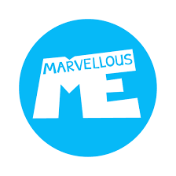
Site Code: rpmeado12
Marvellous Me: Marvellous Me is an app which allows you to communicate with your child’s teacher. Individual join codes will be given in the first few weeks of term.
https://marvellousme.com/

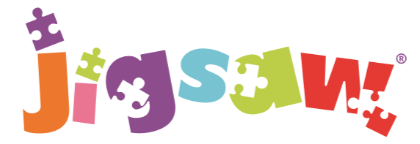
The mindful approach to P.S.H.E.
Celebrating Difference (Year 3)
